DESIGN AND ANALYSIS OF ALGORITHM

LAB EXPERIMENT -8

NAME: Ragavendar
ROLL NO: CH.SC.U4CSE24260

1. HUFFMAN CODING
CODE:
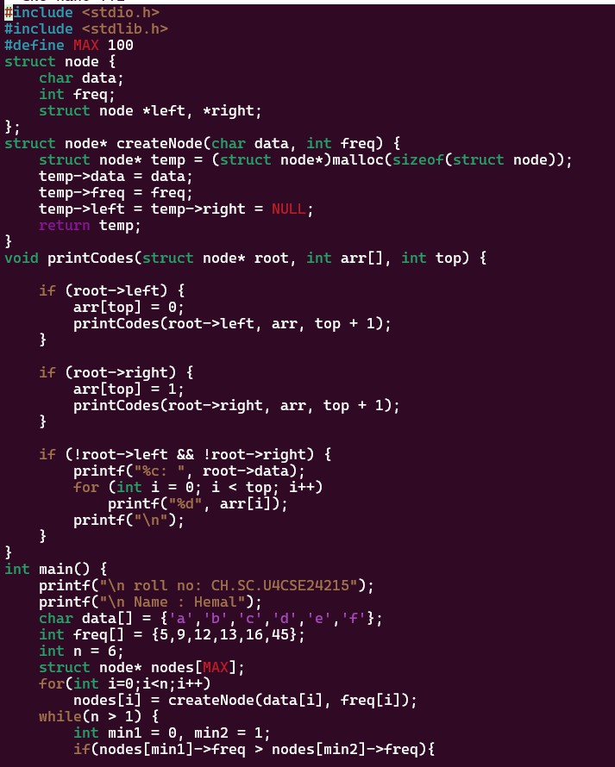

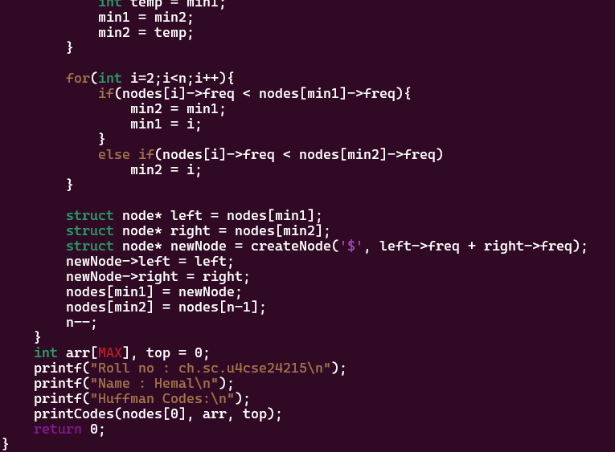
OUTPUT:
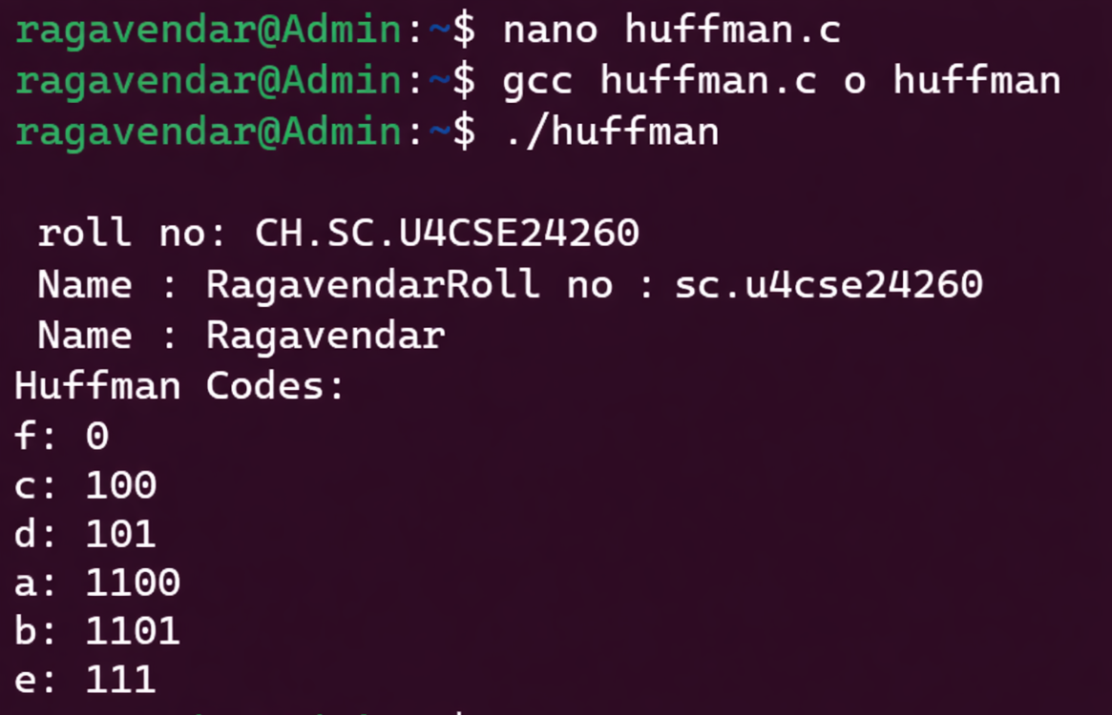

INTERPRETATION:
Huffman coding is a greedy algorithm used for data compression by assigning shorter binary codes to characters with higher frequencies. It builds a binary tree by repeatedly combining the two nodes with the smallest frequencies until a single tree is formed.

